Project Design Document

EC Media Top Up

**Category :** Project document

**Status :** Draft

**Version :**

C1 - Internal use

October 2021

Glossary

|  |  |
| --- | --- |
| **TBC** | To be confirmed |
| **TBD** | To be defined |
| **RPA** | Robotic Process Automation |
| **FTE** | Full time employee |
|  |  |
|  |  |

Table of Contents

1. Executive Summary 4

1.1 Purpose of this Document 4

1.2 High Level Scope 4

1.3 Key Stakeholders 4

1.4 Initial process qualification 4

2. System/Applications 6

3. Process Qualification 7

3.1 Metrics 7

3.1.1 Workload 7

3.1.2 Manual Resource Effort 7

3.1.3 Service Level Agreements 7

3.2 Control 8

3.2.1 Operating hours 8

3.2.2 Business Interaction 8

3.3 Execution 9

3.3.1 Restrictions 9

3.3.2 Alerts 9

3.3.3 Exceptions 9

3.4 Data management 10

3.4.1 Input 10

3.4.2 Error Identification 10

3.5 Preservation 11

3.6 Business Continuity 12

3.6.1 Technology Unavailability 12

3.6.2 Excessive Workload 12

4. Process Overview 13

4.1 Manual Process Description 13

5. Process Description 14

5.1 Process Details 14

5.1.1 Select sub-process(es) to execute 14

5.1.2 Download Media Platform Balance 14

5.1.3 Compare and determine top-up amount 16

5.1.4 Send list(A) to ACCN and ccounting 16

5.1.5 Create down payment in SAP F-47 16

5.1.6 Run payment proposal in SAP F-110 18

5.1.7 Conduct payment in SAP F-110 18

5.1.8 Send final payment list (C) 18

5.1.9 Log in to each store platform 18

5.1.10 Choose media type and charge 18

5.1.11 E-banking approval process (stays manual) 19

5.1.2 Send Mail Result 23

5.2 Exceptions 23

6. Purge Data and GDPR Requests 24

7. Information Security and Risk Compliance Requirements 25

7.1 Personal Information 25

8. Revision History 26

9. Document Approvals 27

9.1 Approval 27

# Executive Summary

## Purpose of this Document

The purpose of this document is to provide an **outline and detailed description of the EC Media Top Up process**.

## High Level Scope

A use case from L’Oreal Finance, the EC Media Top Up process is for:

* **Weekly produce the payment based of the Contact Flights, Media Plan and Media Platform Balances.**

## Key Stakeholders

|  |  |
| --- | --- |
| Business Sponsor |  |
| Process Owner | Patty Ding/Chen Min |
| Process SME(s) |  |
| Business Analyst | BAS Izabela |
|  |  |

## Initial process qualification

|  |  |
| --- | --- |
| Candidate Profile |  |
| Description | Produce the payment based of the Contact Flights, Media Plan and Media Platform Balances. |
| Number of systems and applications used | 7 (Contacts, MS Excel, MS Outlook,SAP,Alimama,ZCT, CMB E-banking) |
| SAP environments  (if relevant) | SAP platform: P62, T-code: F-47, F-110 |
| Frequency | Weekly |
| Volume driver | 26 stores |
| Estimation of FTE spent on the process | 1.3 man days/ month |

|  |  |
| --- | --- |
| Impact Criteria |  |
| Time spent | 1.3 man days/ month |
| Expected qualitative benefits | Major |
| Re-usability |  |

|  |  |
| --- | --- |
| Feasibility Criteria |  |
| Rule-based | Completely based on objective criteria |
| Standardized | Fair level of standardisation, require further standardisation of user data input |
| Structured data | Completely Structured (i.e. in a form/ table/ spreadsheet) |
| Test enabled | Test can be in production environment as the process is only for capturing data |
| IT environment | No dev or test environment available as they are external environments |

# System/Applications

|  |  |  |  |  |  |  |
| --- | --- | --- | --- | --- | --- | --- |
| System/ Application | Version/ Environment | URL | ASM (Application Services Manager) | Accesses required? | Username | User profile Access Rights |
| Microsoft Excel | Excel 2016 | N/A | - | No | N/A | Standard |
| Microsoft Outlook | Outlook 2016 | N/A | - | No | N/A | Standard |
| SAP |  |  |  | Yes |  |  |
| Alimama |  |  |  | Yes |  |  |
| City Bank |  |  |  | Yes |  |  |
| CMB E-banking |  |  |  | Yes |  |  |
| Alipay |  |  |  | Yes |  |  |
| E-banking |  |  |  | Yes |  |  |

# Process Qualification



## Metrics

### Workload

|  |  |
| --- | --- |
| How many statements will treat the bot? |  |
| What is the maximum expected volume? | N/A |
| What is the minimum excepted volume? | N/A |
| Are there any periods when a higher workload is anticipated? | No |
| What are they? | N/A |

### Manual Resource Effort

|  |  |
| --- | --- |
| How many FTE are currently required to perform the process manually? | Approx. 1.3 man days/ month |
| What is the average case handling time? | / store/ day |

### Service Level Agreements

|  |  |
| --- | --- |
| Are there any SLAs this solution must confirm to? |  |
| What are the SLAs? | N/A |
| Should the bot be expected to recognize an SLA breach? If so how? | N/A |

## Control

### Operating hours

|  |  |
| --- | --- |
| Will the bot run outside normal working hours? |  |
| What time will the bot start? | 6 am (UTC+8), daily |
| Will the bot work to a stop time? | No, work until all transactions have been reconciled |
| What days of the week will the bot run? | Every Monthly |
| Are there any days or times when the bot must not run? | No |

### Business Interaction

|  |  |
| --- | --- |
| What part of the Business play within the end-to-end process? |  |
| Will the Business supply new work to the bot implementation? | No |
| Will the Business resubmit exception cases to the bot? | No |

* + 1. Process compliance to Global SOP

|  |  |
| --- | --- |
| Is the process described in the Global SOP? | No |
| Is the "as is" candidate process in line with the Global SOP? | No |
| Is the Global Process Owner informed? | N/A |

## Execution

### Restrictions

|  |  |
| --- | --- |
| Are there any business thresholds that must be adhered to? | No |
| What are they? | N/A |
| Are there any time windows or periods when any of the systems/applications are unavailable? | No, unless external systems crash down |
| List the systems/applications and where they are unavailable. | N/A |

### Alerts

|  |  |
| --- | --- |
| Will the bot need to send out any alerts? | Yes |
| What events should trigger an alert? | Exceptions and/ or errors |
| How will alerts be sent? | Email notification |
| Who will receive alerts? | Key contact(s) registered in the configuration file |

### Exceptions

|  |  |
| --- | --- |
| How will exceptions be sent back to the Business? | Email notification |
| What will be the file structure or message format used for exceptions? Where relevant, provide an example of the required output. | An email template defined by business will be used by the bot |
| When will they be sent? | In case of other error cases |
| Where will they be sent? | Key contact(s) registered in the configuration file |

## Data management

### Input

|  |  |
| --- | --- |
| What input will feed work into the solution? | Mapping table (e.g. business rules, mapping rules)  Configuration file (e.g. execution flag, store accounts data, running hour) |

### Error Identification

|  |  |
| --- | --- |
| Can error be uniquely identified? | Yes |
| What field or combination of fields will be used as the identifier? Only non-sensitive data should be used as an identifier. | No |
| It is possible that the solution could be supplied duplicate cases? | No |
| What would be the consequence of working a case more than once? | N/A |
| Once detected, how should duplicate be dealt with? | N/A |
| It is possible that a case can legitimately reappear at a later date? | N/A |

## Preservation

|  |  |
| --- | --- |
| How long should input date be kept for? | 1 month |
| How long should work queue be kept for? | 7 Day |
| How long should output data be kept for? | 6 months |

## Business Continuity

### Technology Unavailability

|  |  |
| --- | --- |
| If the bot became inoperable and the current DR strategy was unable to ensure availability how continuity should be achieved? | Business reconcile the transactions of the day manually |
| How would the Business like to be informed of RPA unavailability? | Email notification |
| What is the business effect of the process not running for one hour? | No impact in case of one hour delay |
| What is the business effect of the process not running for four hours? | No effect in case of four hours delay |

### Excessive Workload

|  |  |
| --- | --- |
| Is it possible that the solution could be overwhelmed by an excessive workload? | No |
| Quantify an overload threshold | N/A |
| Is this solution required to respond to such an event? | N/A |
| How would this be achieved? | N/A |
| How should the Business be informed? | N/A |
| How should the Business deal with the situation? | N/A |

# Process Overview



## Manual Process Description

* Process high level steps:

1. Download Contacts Fllights (stays manual)
2. Download Media Plan (stays Manual)
3. Conduct payment in SAP F-110 & BCM authorization (stays manual)
4. E-banking approval process (stays manual)

# Process Description

## Process Details

### Select sub-process(es) to execute

* Before starting the bot, user will need to set a configuration file, to set the sub-process(es) to execute in this run
* This provides more flexibility to users, who can select parts of the entire process to run
* The users need to go to Contacts and download Contacts Flights and download Media Plan manually

### Download Media Platform Balance in Alimama

#### Go to alimama.com/index.htm and log in

* Open Google chrome, go to alimama.com/index.htm, login in the Alimama Media Platform for all stores.
* Once the Media Platform login require need to provide the SMS verification code

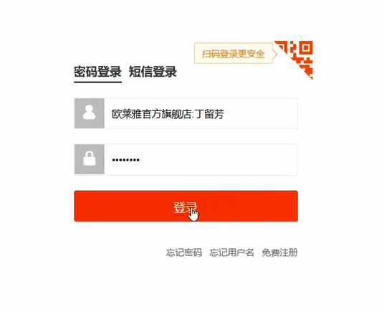

#### Download Media Platform Balance for all stores and their media formats

* Jump to Store page by click “首页”
* Take “直通车” as the sample. Click “直通车”.
* Copy the number of the total balance which is in the “天猫直通车” page.

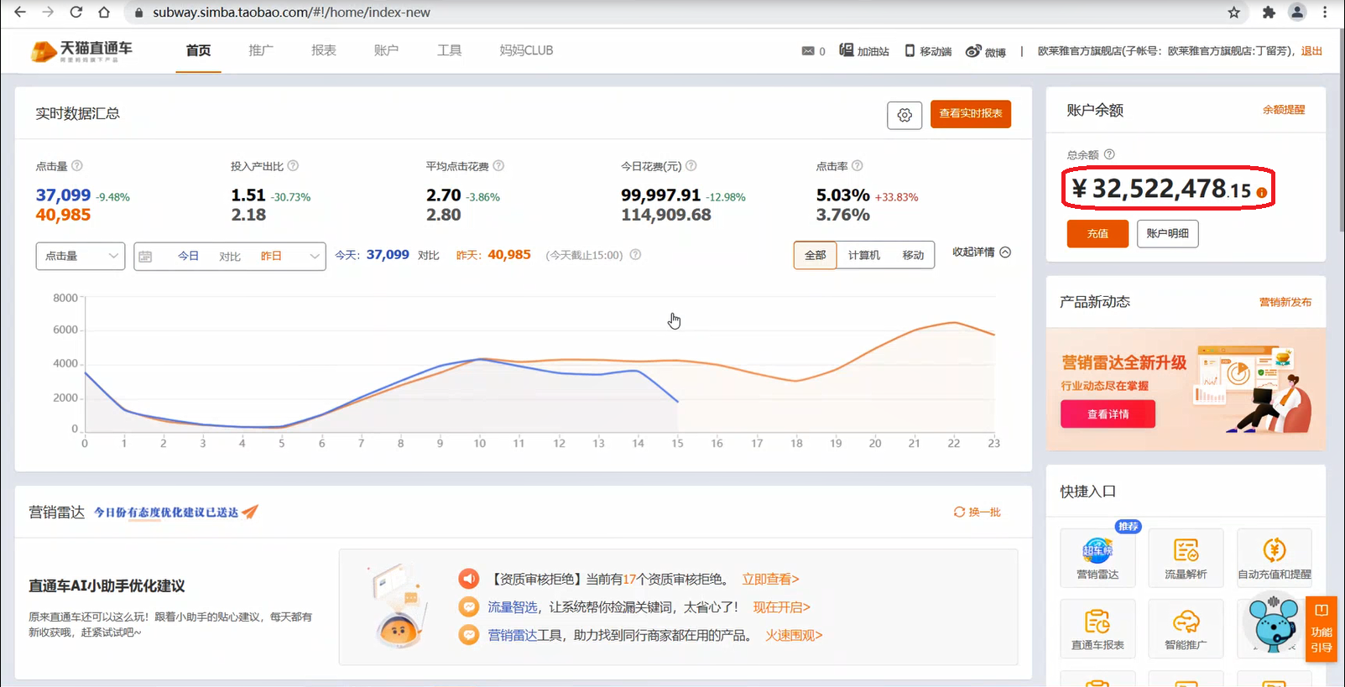

#### Paste of the Media Balances downloaded to the MS Excel file with all the balances

* Paste the account balance in the specify Excel workbook template column named “Media Balance” to compare and determine top-up amount based the store name and the Media name.

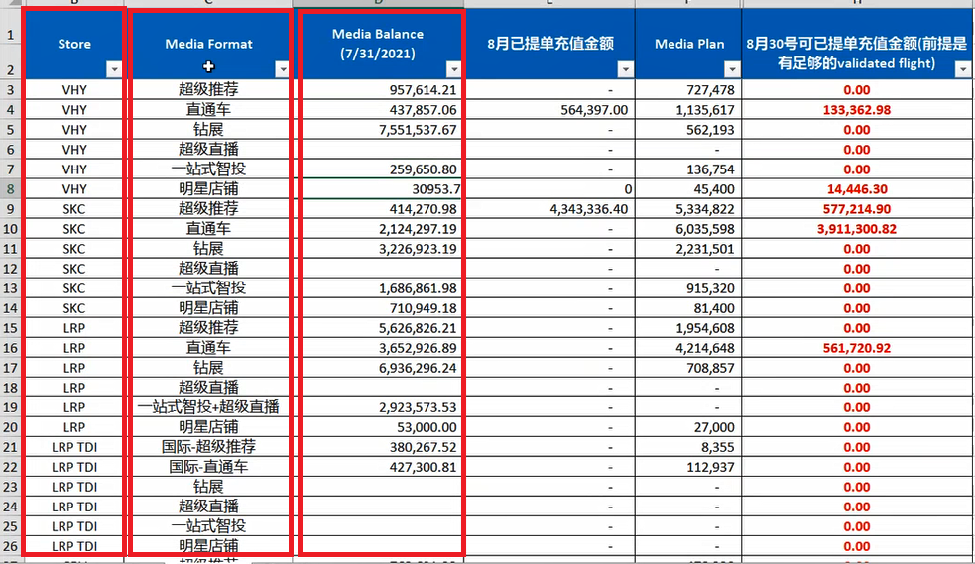

Note: the excel file is shared within Accounting team, Controling team and SME’s team. It is stored on shared folder

### Compare and determine top-up amount

### Download the PDF from “Contacts Flights”

#### Open the Google Chrome and login “Contacts Flights”

#### Open the “Contacts PDF Helper”

* Fill the Flight reference in to the “Contacts PDF Helper”
* Click “PDF 下载”

### Create down payment in SAP F-47

#### Login SAP and go to the SAP Platform P62

* Login SAP go to the SAP platform P62

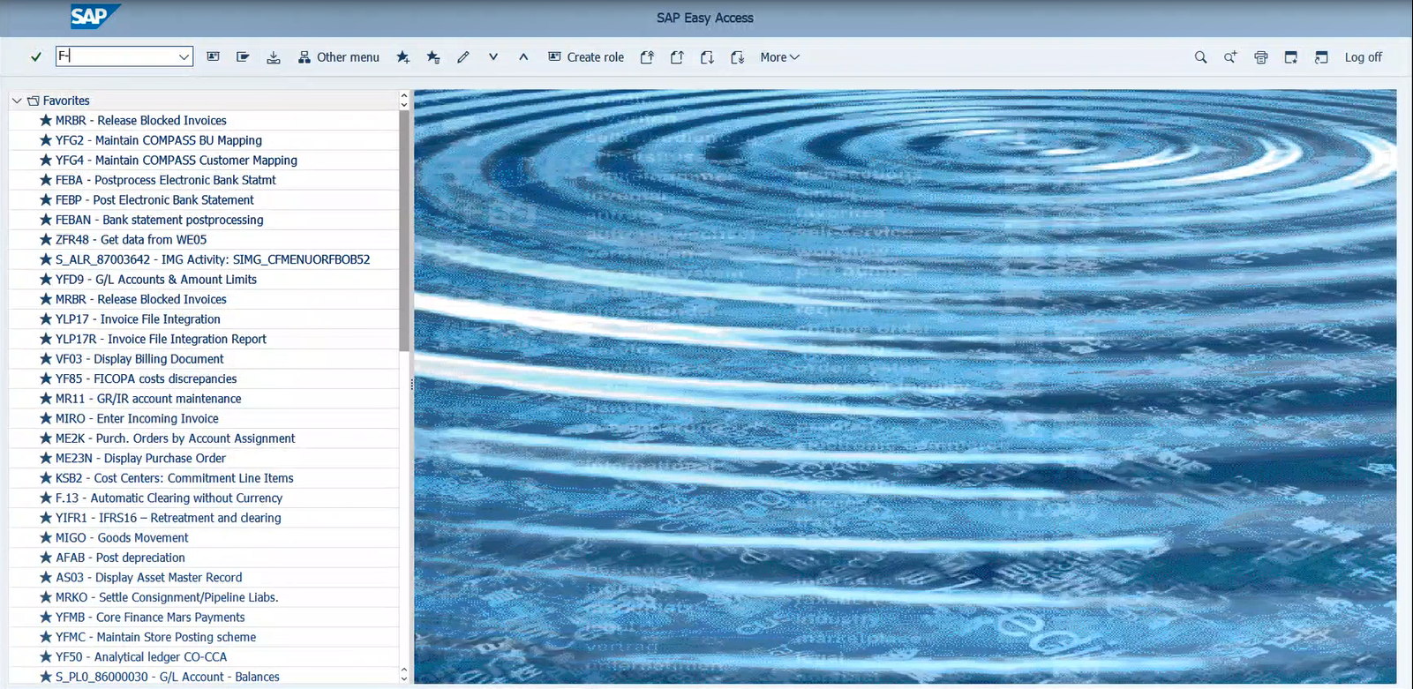

#### Go to t-code F-47

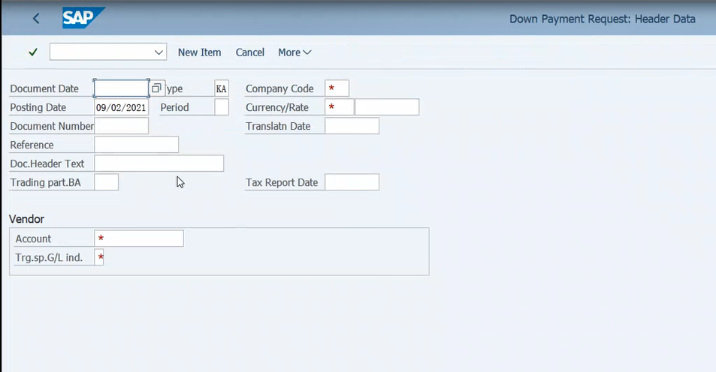

#### Fill in the form with information from the email (for assignment: amount, vendor code) and mapping file (for business area we need a mapping)

Note: Text = short store name &” „ & media type &” „ & the period

### Run payment proposal in SAP F-110

#### Go to t-code F-110

#### Fill in the Run Date (today’s date) and Idetification

#### Fill in the Parameter and Additional log form and click start immediately

#### Create the payment proposal by clicking on Status button

### Conduct payment in SAP F-110

#### Conduct payment in SAP F-110 & BCM authorization

### Send final payment list (C)

#### Send final payment list (C)

### Top up Media Platform Balance in Alimama

#### Go to Alimama Media Platform and log in

#### Click Top Up

#### Input amount then click” Top up Now”

### Pay in the Alipay

#### Choose payment method of” Login Alipay account to pay”, then login to Alipay account, click Next.

#### Login to Alipay account in Alipay platform

#### Double check the payment information

#### Click Payment

### Confirm payment in the E-banking

#### Click Use Corpotate E-banking

#### Select payment bank China Merchant Bank (CMB in short), Click Next

#### Click ”Log in e-banking to pay”

#### Auto link to CMB E-banking, input E-banking user name, login password, u-key password and captcha. Then login CMB E-banking.

#### Select Business Model and payment bank account, input the payment purpose and payment description, souble check the payment amount, then confirm.

### Reconcile the payment information

#### Go to Alipay and check the payment detail

#### Reconcile the payment information with payment list

### E-banking approval process (stays manual)

#### Inform E-banking authorization

#### E-banking approval process

### Send Mail Result

* When the robot finishes running, send the file of the above download result template style to the mailbox of the specified user

## Exceptions

Email execution summary:

* Generate an execution summary as Excel file at the end of the entire process
* Put in the execution result of each sub process/ step based on the RPA log

## Send email for business exception

## Business exception – Cannot login Alimama media platform

**From:** Robot

**To：** Min.CHEN@loreal.com; Patty.DING@loreal.com（Maintain in Config file）

**Subject：**EC Media Top Up Business exception – Alimama media platform login issue – MM.DD.YYYY

**Email body：**

Hi Team,

（此邮件由机器人自动发送，请勿直接回复。）

Hello Sir/Madam，

由于登录验证程序出现问题，机器人在阿里妈妈平台无法进行正常的用户登录，

为了避免影响您正常运行相关流程，请您做好相应处理。给您带来不便，敬请谅解。

Kind regards,

PSSC Robot, L’oreal

## Business exception – Cannot login Contacts Flights

**From:** Robot

**To：** Min.CHEN@loreal.com; Patty.DING@loreal.com（Maintain in Config file）

**Subject：**EC Media Top Up Business exception– Contacts Flights login issue – MM.DD.YYYY

**Email body：**

Hi Team,

（此邮件由机器人自动发送，请勿直接回复。）

Hello Sir/Madam，

由于登录验证程序出现问题，机器人在Contacts Flights无法进行正常的用户登录，

为了避免影响您正常运行相关流程，请您做好相应处理。给您带来不便，敬请谅解。

Kind regards,

PSSC Robot, L’oreal

## Business exception – Cannot login ERP system

**From:** Robot

**To：** Min.CHEN@loreal.com; Patty.DING@loreal.com（Maintain in Config file）

**Subject**：EC Media Top Up Business exception – ERP system login issue – MM.DD.YYYY

**Email body：**

Hi Team,

（此邮件由机器人自动发送，请勿直接回复。）

Hello Sir/Madam，

由于登录验证程序出现问题，机器人在SAP无法进行正常的用户登录，

为了避免影响您正常运行相关流程，请您做好相应处理。给您带来不便，敬请谅解。

Kind regards,

PSSC Robot, L’oreal

## Business exception – Cannot login Alipay

**From:** Robot

**To：** Min.CHEN@loreal.com; Patty.DING@loreal.com（Maintain in Config file）

**Subject：**EC Media Top Up Business exception – Alipay login issue – MM.DD.YYYY

**Email body：**

Hi Team,

（此邮件由机器人自动发送，请勿直接回复。）

Hello Sir/Madam，

由于登录验证程序出现问题，机器人在支付宝无法进行正常的用户登录，

为了避免影响您正常运行相关流程，请您做好相应处理。给您带来不便，敬请谅解。

Kind regards,

PSSC Robot, L’oreal

## Business exception – Cannot login E-banking

**From:** Robot

**To：** Min.CHEN@loreal.com; Patty.DING@loreal.com（Maintain in Config file）

**Subject：**EC Media Top Up Business exception – E-banking login issue – MM.DD.YYYY

**Email body：**

Hi Team,

（此邮件由机器人自动发送，请勿直接回复。）

Hello Sir/Madam，

由于登录验证程序出现问题，机器人在招商银行网上银行平台无法进行正常的用户登录，

为了避免影响您正常运行相关流程，请您做好相应处理。给您带来不便，敬请谅解。

Kind regards,

PSSC Robot, L’oreal

**From:** Robot

**To：** Min.CHEN@loreal.com; Patty.DING@loreal.com（Maintain in Config file）

**Subject：**EC Media Top Up Business exception – E-banking login issue – MM.DD.YYYY

**Email body：**

Hi Team,

（此邮件由机器人自动发送，请勿直接回复。）

Hello Sir/Madam，

由于登录验证程序出现问题，机器人在招商银行网上银行平台无法进行正常的用户登录，

为了避免影响您正常运行相关流程，请您做好相应处理。给您带来不便，敬请谅解。

Kind regards,

PSSC Robot, L’oreal

## Business exception – Cannot login U-Key

**From:** Robot

**To：** Min.CHEN@loreal.com; Patty.DING@loreal.com（Maintain in Config file）

**Subject**：EC Media Top Up Business exception – U-key login issue – MM.DD.YYYY

**Email body**：

Hi Team,

（此邮件由机器人自动发送，请勿直接回复。）

Hello Sir/Madam，

由于登录验证程序出现问题，机器人在U盾无法进行正常的用户登录，

为了避免影响您正常运行相关流程，请您做好相应处理。给您带来不便，敬请谅解。

Kind regards,

PSSC Robot, L’oreal

# Purge Data and GDPR Requests

N/A

# Information Security and Risk Compliance Requirements

The solution’s architecture and design should be in accordance with KPMG’s Information Security and Risk requirements.



## Personal Information

|  |  |
| --- | --- |
| 1. Is there personal information included in the process? If yes, please explain what personal information is being referred to and for how long can the digital worker keep it? (Example: full name of clients) | No |
| 1. If the answer to 1 above was yes the work will need to be undertaken by a digital worker hosted in KPMG internal servers? | N/A |
| 1. Name and cloud service of digital worker process is to be assigned to. | N/A |

# Revision History

|  |  |  |  |
| --- | --- | --- | --- |
| Version | Date | Created/ Reviewed by | Summary of Changes |
|  |  |  |  |
|  |  |  |  |
|  |  |  |  |

# Document Approvals

## Approval

|  |  |  |  |
| --- | --- | --- | --- |
| Project role | Name & Position | Signature | Date |
|  |  |  |  |
|  |  |  |  |
|  |  |  |  |